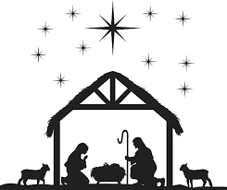
Christmas Eve Family Mass at St Johns
(Carols at 5:30; Mass at 6:00 pm)
Would your child(ren) like to be part of telling the story of the Nativity? If so, please bring them to two short rehearsals at 11 am, after 10 am Mass on Sunday Dec 15th and 22nd.
Children who are taking part will need to be at the church by 5 pm on Christmas Eve. All children are welcome to participate as angels, shepherds and general townsfolk. We have costumes, but if your child wants to be a certain character, please feel free to create their own costume if you wish.
We look forward to seeing your child, grandchild, or special friend.
For further information please contact Mary Parsissons on 0448 259 747 or mparsissons@bigpond.net.au

