EUCHARIST

Children show readiness to prepare to celebrate the sacrament of Eucharist when:

- They attend the Saturday Vigil Mass or Sunday
Mass with family and/or friends.
- Prayer is becoming a more important part of their family life.
- They have a desire to be close to Jesus in love and friendship.
- They show their love for Jesus and for one another.
- They spontaneously recognise the needs of other people.
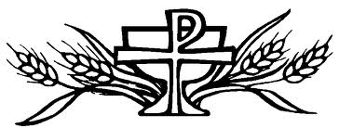
Is my child ready
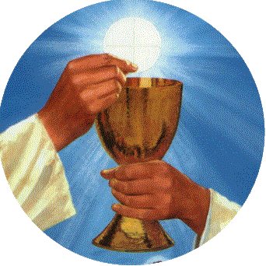

to celebrate the Sacraments?
QUESTIONS ABOUT YOUR CHILD’S READINESS TO CELEBRATE THE SACRAMENTS

The following questions may assist you in determining your child’s readiness to prepare to celebrate the Sacraments.

RECONCILIATION

Children show readiness to prepare to celebrate the
Sacrament of Reconciliation when:

- They know the difference between right and wrong.
- They begin to recognise the needs of other people.
- They are capable of reflecting on their actions when asked about them.
- They show remorse and a desire to be sorry for the times when they have done something wrong.
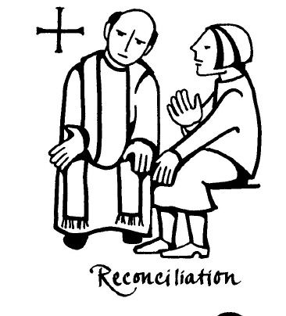
CONFIRMATION

Children show readiness to prepare to celebrate the sacrament of Confirmation when:

- They have reached the age of reason.
- They are capable of nurturing a personal faith.
- They attend the Saturday Vigil Mass or Sunday Mass with family and/or friends.
- They are open to the gifts of the Holy Spirit.
- They are open to prayer becoming part of their family life.
- They show a sense of reverence for God.
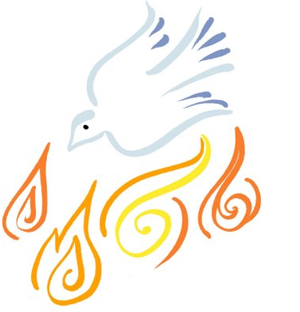
- They show a desire to be more actively involved in their faith community.

It is a requirement of the Church that candidates for
Confirmation and First Eucharist have celebrated
the sacrament of Reconciliation.

